25.2 Editors - Properties Editor - Render Properties Tab
Detailed Table of content 4
Render Tab 11
Cycles Feature Set 11
Cycles Device 12
Color Management panel - All Renderers 12
Display Device 12
View Transform 12
Look 13
Exposure 13
Gamma 13
Sequencer Color Space 13
Use Curves 13
Cycles and Eevee - Freestyle panel 15
What is FreeStyle? 15
Enable 16
Line Thickness Mode 16
Line Thickness 16
Cycles - Sampling panel 16
Presets 17
Integrator 17
Render 17
Viewport 17
Sub Samples (Branched Path Tracing) 17
Adaptive Sampling 18
Denoising 18
Advanced 18
Cycles - Light Paths panel 19
Presets 19
Max Bounces 20
Clamping 20
Caustics 20
Cycles - Volumes panel 21
Step Size 21
Max Steps 21
Cycles - Hair panel 21
Shape 21
Primitive 22
Cycles - Simplify panel 22
Enable 22
Viewport 22
Render 23
Culling 23
Grease Pencil 24
Cycles - Motion Blur panel 24
Enable 24
Position 24
Shutter 24
Rolling Shutter 25
Rolling Sutter Duration 25
Shutter Curve 25
Cycles - Film panel 26
Exposure 26
Pixel Filter 26
Cycles - Performance panel 26
Threads 27
Tiles 27
Acceleration Structure 27
Final Render 28
Viewport 28
Cycles - Bake panel 28
Settings for all Texture types 29
Workbench - Lighting panel 32
Flat 32
Studio 32
Matcap 32
Workbench - Color panel 33
Material 33
Object 33
Vertex 33
Single 33
Random 33
Texture 33
Workbench - Options panel 34
X Ray 34
Backface Culling 34
Show X-Ray 34
Shadow 34
Cavity 34
Outline 35
Specular Lighting 35
Eevee - Sampling panel 35
Viewport Samples 35
Render Samples 35
Viewport Denoising 35
Eevee - Ambient Occlusion panel 35
Enable 35
Distance 36
Factor 36
Trace Precision 36
Bent Normals 36
Bounces Approximation 36
Eevee - Bloom panel 36
Enable 36
Threshold 36
Knee 36
Radius 36
Color 36
Intensity 36
Clamp 37
Eevee - Depth of Field panel 37
Max Size 37
Eevee - Subsurface Scattering panel 37
Enable 37
Samples 37
Jitter Threshold 37
Separate Albedo 37
Eevee - Screen Space reflections panel 37
Enable 37
Refraction 37
Half Res Trace 38
Trace Precision 38
Max Roughness 38
Thickness 38
Edge Fading 38
Clamp 38
Eevee - Motion Blur panel 38
Enable 38
Samples 38
Shutter 38
Eevee - Volumetric panel 39
Start 39
End 39
Tile Size 39
Samples 39
Distribution 39
Viewport Volumetric Blending 39
Volumetric Lighting 39
Volumetric Shadows 39
Eevee - Hair panel 40
Hair Shape Type 40
Additional Subdiv 40
Eevee - Shadows panel 40
Method 40
Cube Size 40
Cascade Size 40
High Bit depth 40
Soft Shadows 41
Eevee - Indirect Lighting panel 41
Bake Indirect Lighting 41
Bake Cubemap Only 41
Delete Lighting Cache 41
Auto Bake 41
Diffuse Bounces 41
Cubemap Size 41
Diffuse Occlusion 41
Irradiance Smoothing 41
Clamp Glossy 41
Filter Quality 42
Display 42
Eevee - Film panel 42
Filter Size 42
Overscan 42
Eevee + Workbench - Simplify panel 42
Enable 43
Viewport 43
Render 43
Grease Pencil 43

Detailed Table of content

25.2 Editors - Properties Editor - Render Tab
Detailed Table of content 4
Render Tab 11
Cycles Feature Set 11
Cycles Device 12
Open Shading Language 12
Color Management panel - All Renderers 12
Display Device 12
View Transform 12
Standard 12
Filmic 12
Filmic Log 13
Raw 13
False Color 13
Look 13
Exposure 13
Gamma 13
Sequencer Color Space 13
Use Curves 13
Navigation elements 13
Zoom in and out 14
Tools 14
Reset View 14
Vector Handle 14
Auto Handle 14
Auto Clamped Handle 14
Extend Horizontal 14
Extend Extrapolated 14
Reset Curve 14
Use Clipping 14
Delete Points 14
Black Level 14
White Level 14
Hotkeys for Black and White Level 14
Reset 15
Cycles and Eevee - Freestyle panel 15
What is FreeStyle? 15
Enable 16
Line Thickness Mode 16
Absolute 16
Relative 16
Line Thickness 16
Cycles - Sampling panel 16
Presets 17
Integrator 17
Render 17
Viewport 17
Square Samples 17
Sub Samples (Branched Path Tracing) 17
Diffuse Samples 17
Glossy Samples 17
Transmission Samples 17
AO Samples 17
Mesh Light Samples 17
Subsurface Samples 18
Volume Samples 18
Total Samples 18
Adaptive Sampling 18
Min Samples 18
Noise Threshold 18
Denoising 18
Render 18
Viewport 18
Advanced 18
Seed 18
Animate Seed 18
Pattern 19
Sobol 19
Correlated Multi-Jitter 19
Light Threshold 19
Sample all direct lights (Branched Path Tracing) 19
Sample all indirect lights (Branched Path Tracing) 19
Cycles - Light Paths panel 19
Presets 19
Max Bounces 20
Total 20
Diffuse 20
Glossy 20
Transparency 20
Transmission Bounces 20
Volume 20
Clamping 20
Direct Light 20
Indirect Light 20
Caustics 20
Filter Glossy 20
Reflective Caustics 21
Refractive Caustics 21
Cycles - Volumes panel 21
Step Size 21
Max Steps 21
Cycles - Hair panel 21
Shape 21
Cull Backfaces (Thick) 21
Primitive 22
Triangles 22
Resolution 22
Line Segments 22
Curve Segments 22
Curve Subdivision 22
Cycles - Simplify panel 22
Enable 22
Viewport 22
Max Subdivisions 22
Child Particles 22
Texture Limit 23
AO Bounces 23
Volume Resolution 23
Render 23
Max Subdivisions 23
Child Particles 23
Texture Limit 23
AO Bounces 23
Culling 23
Use Camera Cull 23
Camera cull margin 23
Use Distance Cull 23
Distance 24
Grease Pencil 24
Playback Only 24
Fill 24
Modifiers 24
Shader Effects 24
Layers Tinting 24
Antialiasing 24
Cycles - Motion Blur panel 24
Enable 24
Position 24
Shutter 24
Rolling Shutter 25
Rolling Sutter Duration 25
Shutter Curve 25
Navigation elements 25
Zoom in and out 25
Tools 25
Reset View 25
Vector Handle 25
Auto Handle 25
Auto Clamped Handle 25
Extend Horizontal 25
Extend Extrapolated 25
Reset Curve 25
Use Clipping 26
Delete Points 26
X and Y values 26
Presets 26
Cycles - Film panel 26
Exposure 26
Pixel Filter 26
Type 26
Width 26
Cycles - Performance panel 26
Threads 27
Mode 27
Auto-detect 27
Fixed 27
Threads 27
Tiles 27
Tile size X/Y 27
Order 27
Progressive Refine 27
Acceleration Structure 27
Use Spatial Splits 27
Use Hair BVH 27
BVH Time Steps 28
Final Render 28
Save Buffers 28
Persistent Images 28
Viewport 28
Pixel Size 28
Start Pixels 28
Cycles - Bake panel 28
Settings for all Texture types 29
Bake Button 29
Bake from Multires 29
Bake Type 29
Subsurface 29
Transmission 29
Glossy 29
Diffuse 29
Environment 29
Emit 29
Roughness 29
UV 30
Normals 30
Shadow 30
Ambient Occlusion 30
Combined 30
Influence Sub panel 30
Subsurface, Transmission, Glossy, Diffuse 30
Direct 30
Indirect 30
Color 30
Normal 30
Space 30
Swizzle 30
Combined 31
Direct 31
Indirect 31
Diffuse 31
Glossy 31
Transmission 31
Subsurface 31
AO 31
Emit 31
Selected to Active 31
Cage 31
Ray Distance 31
Output Sub panel 32
Margin 32
Clear Image 32
Workbench - Lighting panel 32
Flat 32
Studio 32
Light library browser 32
Rotation 32
User Preferences 32
Matcap 32
User Preferences 33
Flip Matcap 33
Workbench - Color panel 33
Material 33
Object 33
Vertex 33
Single 33
Random 33
Texture 33
Workbench - Options panel 34
X Ray 34
Backface Culling 34
Show X-Ray 34
X-Ray Alpha 34
Shadow 34
Shadow Intensity 34
Shading Shadow Options 34
Cavity 34
World 34
World Space / Ridge Valley 34
Shading Options 34
Screen 35
Screen Space / Ridge Valley 35
Both 35
Outline 35
Outline Color 35
Specular Lighting 35
Eevee - Sampling panel 35
Viewport Samples 35
Render Samples 35
Viewport Denoising 35
Eevee - Ambient Occlusion panel 35
Enable 35
Distance 36
Factor 36
Trace Precision 36
Bent Normals 36
Bounces Approximation 36
Eevee - Bloom panel 36
Enable 36
Threshold 36
Knee 36
Radius 36
Color 36
Intensity 36
Clamp 37
Eevee - Depth of Field panel 37
Max Size 37
Eevee - Subsurface Scattering panel 37
Enable 37
Samples 37
Jitter Threshold 37
Separate Albedo 37
Eevee - Screen Space reflections panel 37
Enable 37
Refraction 37
Half Res Trace 38
Trace Precision 38
Max Roughness 38
Thickness 38
Edge Fading 38
Clamp 38
Eevee - Motion Blur panel 38
Enable 38
Samples 38
Shutter 38
Eevee - Volumetric panel 39
Start 39
End 39
Tile Size 39
Samples 39
Distribution 39
Viewport Volumetric Blending 39
Volumetric Lighting 39
Enable 39
Light Clamping 39
Volumetric Shadows 39
Enable 39
Samples 40
Eevee - Hair panel 40
Hair Shape Type 40
Animate Property 40
Additional Subdiv 40
Animate Property 40
Eevee - Shadows panel 40
Method 40
Cube Size 40
Cascade Size 40
High Bit depth 40
Soft Shadows 41
Eevee - Indirect Lighting panel 41
Bake Indirect Lighting 41
Bake Cubemap Only 41
Delete Lighting Cache 41
Auto Bake 41
Diffuse Bounces 41
Cubemap Size 41
Diffuse Occlusion 41
Irradiance Smoothing 41
Clamp Glossy 41
Filter Quality 42
Display 42
Cubemap Size 42
Irradiance Size 42
Eevee - Film panel 42
Filter Size 42
Animate Property 42
Overscan 42
Overscan Size 42
Eevee + Workbench - Simplify panel 42
Enable 43
Viewport 43
Max Subdivisions 43
Child Particles 43
Volume Resolution 43
Animate Property 43
Render 43
Max Subdivisions 43
Child Particles 43
Animate Property 43
Grease Pencil 43
Playback Only 43
Fill 44
Modifiers 44
Shader Effects 44
Layers Tinting 44
Antialiasing 44

Render Tab

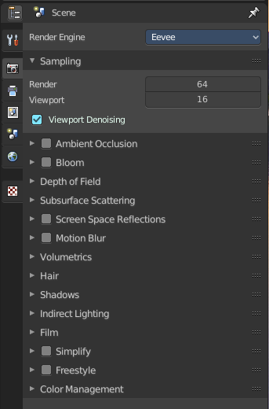
Rendering is the process of calculating a 2D image (or video) from your 3D scene. For this you use a so called render engine.
The Render tab contains the functionality and settings around the available render engines in Bforartists. And Choose the renderer with which you render your still or animation with.
There are three different render engines available. Workbench, Eevee and Cycles.
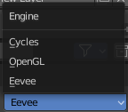

Cycles is a so called offline renderer. It is an unbiased physically correct renderer with some biased adjustments to make it usable for animations.
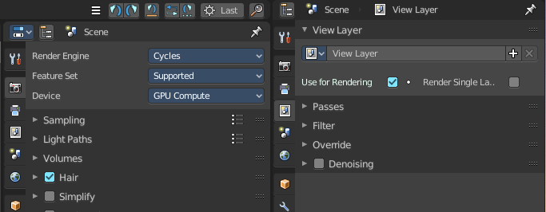
Cycles can render at the CPU or the GPU.
Eevee and Workbench are both so called Realtime Renderers. They both render at the GPU. Workbench relies at the OpenGL render features of the graphics card. Eevee is a full independent realtime render engine.
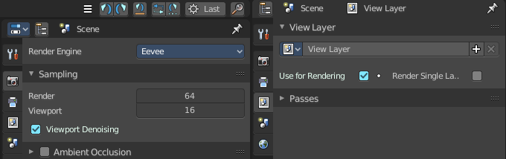
All three renderers have different settings. And the choice of the renderer influences the tab and panel content of the whole Scene section.
This content will be covered in the chapters for the other tabs.

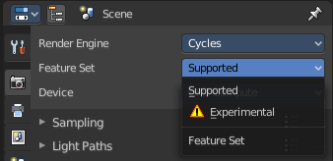
Cycles Feature Set
When you choose Cycles then you will see a new drop down box called Feature set. Cycles has two feature set settings. Supported and Experimental.
Supported means you have all common Cycles settings available.
Experimental means that you have access to some further experimental features of Cycles, which are somehow functional, but are still experimental features. Like Adaptive subdivision. Those features may or may not work proper. Use at own risk!

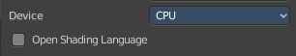
Cycles Device
When you turn on Cuda in the User Preferences then you will get a Device drop down box to choose if you want to render with the CPU or the GPU.

Open Shading Language
When you render with Cycles at the CPU, then you can choose to use the Open Shading Language.

Color Management panel - All Renderers
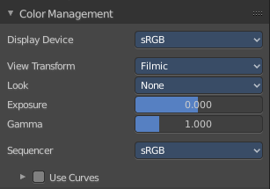
Color management is important to create renders and assets that are physically accurate and look great on multiple display devices. It is used both to ensure all parts of the pipeline interpret colors correctly, and to make artistic changes like exposure and color grading.
Bforartists color management is based on the OpenColorIO library. By using the same OpenColorIO configuration in multiple applications, the same color spaces and transforms will be available for consistent results.
In the Color Management panel you will find the settings around color management. It allows an artist to make sure that an image stays the same from rendering, to saving, to post-processing. Color management also allows an artist to tweak things like exposure, gamma, or the overall color grade.
The Color Management panel is the same for all render engines.

Display Device
The device that the image is being viewed on. Your monitor.
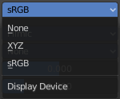
Most computer monitors are configured for the sRGB color space.
Color management can also be disabled by setting the device to None.

View Transform
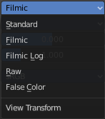
Choose between different ways to view the image on the same monitor.

Standard
Does no extra conversion besides the conversion for the display device.

Filmic
For more photo realistic results and better handling of high dynamic range. The contrast can be adjusted by changing the Look option for the Filmic view transform.

Filmic Log
Converts to Filmic log color space. This can be used for export to color grading applications, or to inspect the image by flattening out very dark and light areas.

Raw
Intended for inspecting the image but not for final export. Raw gives the image without any color space conversion.

False Color
Shows a heat map of image intensities, to visualize the dynamic range.

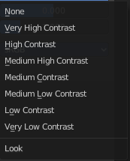
Look
Adjust the contrast.

Exposure
Used to control the image brightness (in stops) applied before color space conversion. The calculation is: output_value=render_value×2(exposure)

Gamma
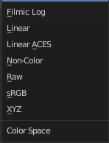
Extra gamma correction applied after color space conversion. Note that the default sRGB or Rec709 color space conversions already include a gamma correction of approximately 2.2 (except the Raw and Log views), so this would be applied in addition to that.

Sequencer Color Space
The color space that the sequencer operates in. By default, the sequencer operates in sRGB space, but it can also be set to work in Linear space like the Compositing nodes, or another color space. Different color spaces will give different results for color correction, cross fades, and other operations.

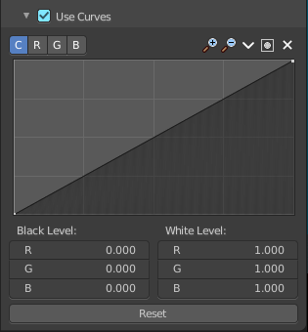
Use Curves
Adjust RGB Curves to control image colors before color space conversion.

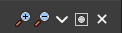
Navigation elements
The navigation elements at the top are described from left to right.

Zoom in and out
The two buttons with the magnifying glass at it zooms in and out in the curve window.

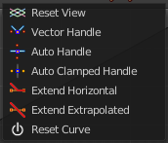
Tools
Tools is a menu that contains some cuve related tools.

Reset View
Resets the curve windows zoom.

Vector Handle
Set handle type to Vector.

Auto Handle
Set handle type to Auto.

Auto Clamped Handle
Set handle type to Auto Clamped.

Extend Horizontal
Causes the curve to stay horizontal before the first point and after the last point.

Extend Extrapolated
Causes the curve to extrapolate before the first point and after the last point, based on the shape of the curve.

Reset Curve
Resets the curve to the initial shape.


Use Clipping
Clipping options. Set up clipping for the stroke.

Delete Points
Deletes selected curve points.

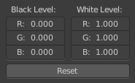
Black Level
The color that Black is mapped to.

White Level
The color that White is mapped to.

Hotkeys for Black and White Level

You may want to sample the black and white level colors directly in the image by clicking at an area. There are hotkeys for that.
Ctrl + Left Mouse click in the image sets the Black level value from that position.
Shift + Left Mouse click in the image sets the White Level value from that position.
To see the result you need to tick the View as Render button.
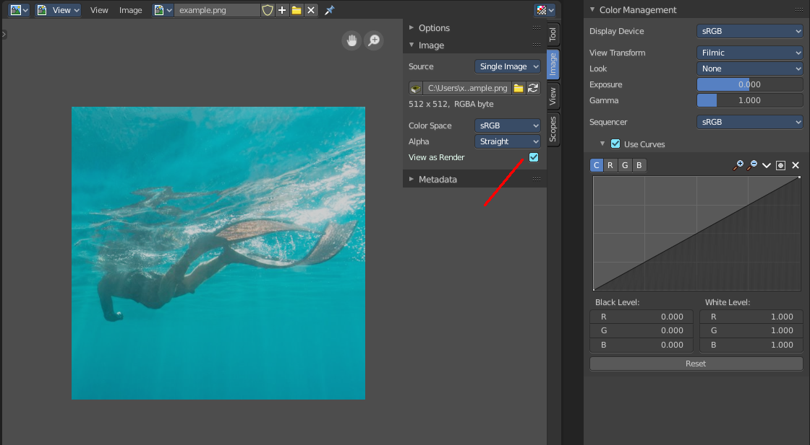

Reset
Resets the Curve and the Black and White Level values to the default values.

Cycles and Eevee - Freestyle panel

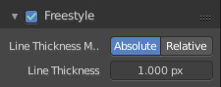
What is FreeStyle?
Freestyle is an edge- and line-based non-photorealistic (NPR) rendering engine that works on top of Cycles. It relies on mesh data and z-depth information to draw lines on selected edge types. Various line styles can be added to produce artistic or technical looks.
The two operating modes - Python Scripting and Parameter Editor - allow a diversity of line styles and results. Line styles such as Japanese big brush, cartoon, blueprint, thickness-with-depth are already pre-scripted in Python. The Parameter Editor mode allows intuitive editing of features such as dotted lines and easy setup of multiple line types and edge definitions.
There are more Freestyle settings in the View Layer tab wAdjust and define various parameters.
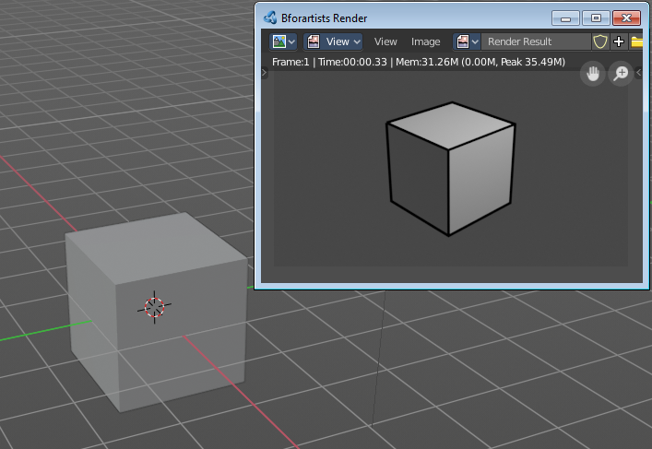
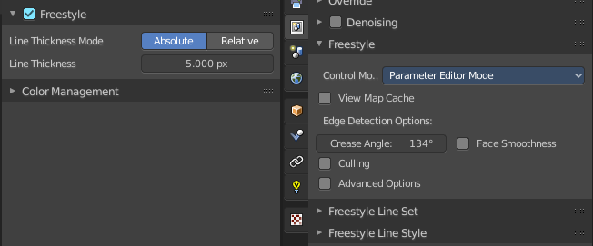

Enable
In the header is a checkbox where you can enable the Freestyle renderer.

Line Thickness Mode

Absolute
The line thickness is given by a user-specified number of pixels. The default value is 1.0.

Relative
The unit line thickness is scaled by the proportion of the present vertical image resolution to 480 pixels. For instance, the unit line thickness is 1.0 with the image height set to 480, 1.5 with 720, and 2.0 with 960.

Line Thickness
Line Thickness is only available for Absolute line thickness. The base line thickness in pixels.

Cycles - Sampling panel
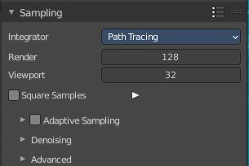
Adjust the samples for Cycles. And enable denoising.

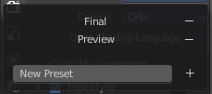
Presets
In the header you will find a Presets menu to choose between presets and define your own presets.

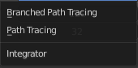
Integrator
Choose between Path Tracing and Branched Path Tracing. Branched path tracing branches up on first hit. This makes each sample slower, since now there is more to calculate. But this will increase quality and reduce noise.

Render
Number of samples for the rendered image.

Viewport
Number of samples for rendering in the viewport.

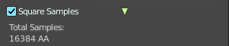
Square Samples
Squares the amount samples.

Sub Samples (Branched Path Tracing)
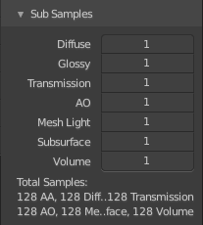
This sub panel just appears when you choose Branched Path Tracing.

Diffuse Samples
Number of diffuse bounce samples to take for each AA sample.

Glossy Samples
Number of glossy bounce samples to take for each AA sample.

Transmission Samples
Number of transmission bounce samples to take for each AA sample.

AO Samples
Number of ambient occlusion samples to take for each AA sample.

Mesh Light Samples
Number of mesh light samples to take for each AA sample.

Subsurface Samples
Number of subsurface scattering samples to take for each AA sample.

Volume Samples
Number of volume scattering samples to take for each AA sample.

Total Samples
An info string that tells you the total number of samples with the current settings.

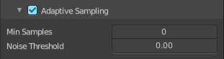
Adaptive Sampling

Min Samples
The minimum number of samples for adaptive sampling. Zero for automatic settings based at the number of AA samples.

Noise Threshold
The noise level at which the sampling should stop. Zero for automatic settings based at the number of AA samples.

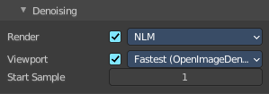
Denoising
Enable denoisingin the final render and the viewport rendering

Render
Enable render denoising. Currently just the NLM method without any further settings.

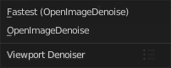
Viewport
Enable viewport denoising. Two methods available.

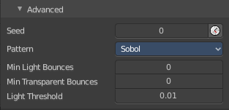
Advanced

Seed
Seed value for integrator to get different noise patterns.

Animate Seed
The clock icon besides the Seed value. Enable it to get different seed values for animation. Without animated seed you will get visible patterns in animations.

Pattern
Random sampling pattern used by the integrator.

Sobol
Uses a Sobol pattern to decide the random sapling pattern used by the integrator.

Correlated Multi-Jitter
Uses a Correlated Multi-Jitter pattern to decide the random sapling pattern used by the integrator.

Light Threshold
Terminates light samples when the light contribution is below this value. This gives more noise, but renders faster. Type in 0 to disable this feature.

Sample all direct lights (Branched Path Tracing)
Sample all direct lights rather than picking one random.

Sample all indirect lights (Branched Path Tracing)
Sample all indirect lights rather than picking one random.

Cycles - Light Paths panel
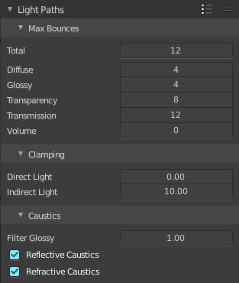
Here you will find all settings regarding light paths.

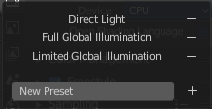
Presets
In the header you will find a Presets menu to choose between presets and define your own presets.

Max Bounces
A sub menu with the Maximum Bounces settings.

Total
Total maximum number of bounces.

Diffuse
Maximum number of diffuse bounces.

Glossy
Maximum number of glossy bounces.

Transparency
Maximum number of transparency bounces.

Transmission Bounces
Maximum number of transmission bounces.

Volume
Maximum number of volume scattering bounces.

Clamping
A sub menu with the Clamping settings. Clamping will reduce noise at the cost of accuracy.

Direct Light
The maxium value for a direct sample. Zero means disabled.

Indirect Light
The maximum value for a indirect sample. Zero means disabled.

Caustics
A sub menu with caustics and filter glossy settings.

Filter Glossy
When using a value higher than 0.0, this will blur glossy reflections after blurry bounces, to reduce noise at the cost of accuracy. 1.0 is a good starting value to tweak.
Some light paths have a low probability of being found while contributing much light to the pixel. As a result these light paths will be found in some pixels and not in others, causing fireflies. An example of such a difficult path might be a small light that is causing a small specular highlight on a sharp glossy material, which we are seeing through a rough glossy material. In fact in such a case we practically have a caustic.
With path tracing it is difficult to find the specular highlight, but if we increase the roughness on the material, the highlight gets bigger and softer, and so easier to find. Often this blurring will hardly be noticeable, because we are seeing it through a blurry material anyway, but there are also cases where this will lead to a loss of detail in lighting.

Reflective Caustics
Disable reflective caustics. Path tracing supports rendering of caustics with a sufficient number of samples. But in practice it may be inefficient to the point that there is just too much noise.

Refractive Caustics
Disable refractive caustics. Path tracing supports rendering of caustics with a sufficient number of samples. But in practice it may be inefficient to the point that there is just too much noise.

Cycles - Volumes panel

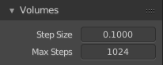
Adjust the volume sampling.

Step Size
Distance between volume shader samples when rendering the volume. Lower values give more accurate and detailed results but also increased render time.

Max Steps
Maximum number of steps through the volume before giving up, to protect from extremely long render times with big objects or small step sizes.

Cycles - Hair panel
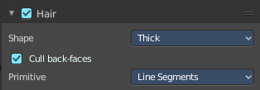
Adjust the settings for Hair particles.

Shape
Choose between the shape Thick and Ribbon

Cull Backfaces (Thick)
Cull the backface geometry. Just available for the shape Thick.

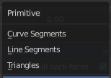
Primitive
What primitive to use for the Hair.

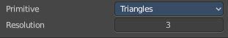
Triangles
Use Triangle primitives.

Resolution
The resolution of the triangle mesh.

Line Segments
Use Line Sement primitives.

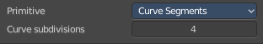
Curve Segments
Use Curve primitives.

Curve Subdivision
The subdivision of the curve primitive.

Cycles - Simplify panel
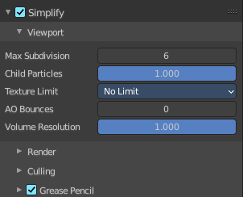

Sometimes you want to simplify the rendering without to loose the already tweaked settings and adjustments. For test renderings for example. Simplify allows you to set global limits on subdivision, shadow samples and more.

Enable
In the header is a checkbox to enable Simplify.

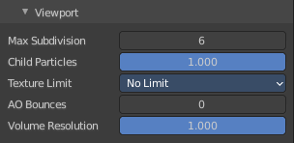
Viewport
This section affects the rendering with cycles in the Viewport.

Max Subdivisions
Limit the number of maximum subdivisions.

Child Particles
Limit the number of child particles.

Texture Limit
Automatically scales down textures to the chosen value.

AO Bounces
Limit the number of Ambient Occlusion Bounces.

Volume Resolution
Simplify volumes by adjusting volume percentage of volume objects in viewport.

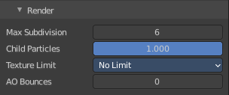
Render
This section affects the final rendering.

Max Subdivisions
Limit the number of maximum subdivisions.

Child Particles
Limit the number of child particles

Texture Limit
Automatically scales down textures to the chosen value.

AO Bounces
Limit the number of Ambient Occlusion Bounces.

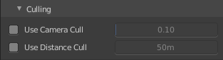
Culling
Contains Culling settings. Culling means that the affected geometry is excluded from calculation.

Use Camera Cull
Allow objects to be culled based on the Camera Frustum. Frustum is the region of the 3D space that gets displayed by the camera, the field of view.

Camera cull margin
The margin for the camera space culling.

Use Distance Cull
Allow objects to be culled based on the distance to the camera.

Distance
The distance after which the objects gets culled away.

Grease Pencil

Playback Only
Simplify the grease pencil strokes only during playback.

Fill
Display Fill strokes in viewport.

Modifiers
Display Modifiers.

Shader Effects
Display Shader effects.

Layers Tinting
Display layer tint.

Antialiasing
Use antialiasing to smooth stroke edges.

Cycles - Motion Blur panel
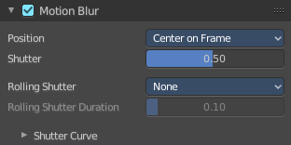
Enable Motion Blur and adjust the settings.

Each object has also its own settings to control motion blur. These options can be found in the corresponding Object tab of the Properties editor.

Enable
In the header is a checkbox to enable Simplify.

Position
Controls at what point the shutter opens in relation to the frame.

Shutter
Time between frames over which motion blur is computed. Shutter time 1.0 blurs over the length of 1 frame, 2.0 over the length of two frames, from the previous to the next.

Rolling Shutter
Enable Rolling Shutter.

Rolling Sutter Duration
Controls balance between pure rolling shutter effect and pure motion blur effect. With zero being no rolling shutter and one being all rolling shutter.

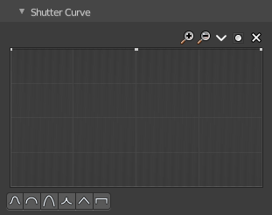
Shutter Curve
Sutter curve is a sub menu wAdjust a curve for the shutter effect.

Navigation elements
The navigation elements at the top are described from left to right.

Zoom in and out
The two buttons with the magnifying glass at it zooms in and out in the curve window.

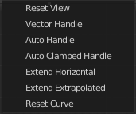
Tools
Tools is a menu that contains some curve related tools.

Reset View
Resets the curve windows zoom.

Vector Handle
Set handle type to Vector.

Auto Handle
Set handle type to Auto.

Auto Clamped Handle
Set handle type to Auto Clamped.

Extend Horizontal
Causes the curve to stay horizontal before the first point and after the last point.

Extend Extrapolated
Causes the curve to extrapolate before the first point and after the last point, based on the shape of the curve.

Reset Curve
Resets the curve to the initial shape.

Use Clipping
Clipping options. Set up clipping for the stroke.

Delete Points
Deletes selected curve points.

X and Y values
The coordinates of the currently selected curve point.

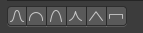
Presets
At the bottom you can find some curve presets.

Cycles - Film panel
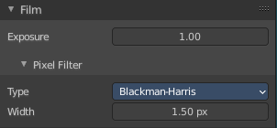

Exposure
Exposure can be used to change the brightness of an image. Different then the Exposure option found in the Color management panel this exposure option works is on the data while the Color management exposure is on the view.

Pixel Filter
The Pixel Filter randomly changes the coordinates of every sample with the given distribution. For example: When the Sobol Sampling Pattern samples near the edge of the pixel, the neighboring pixel might be lit instead with a rather high probability. Pixel filter is used to get rid of aliasing on the sharp edge of very bright objects, like mesh lights.

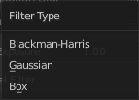
Type
Choose the pixel filter type.

Width
Adjust the pixel filter width.

Cycles - Performance panel

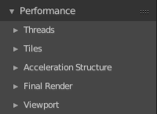
Settings to influence the render performance.

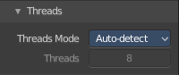
Threads

Mode

Auto-detect
Automatically chooses the amount threads to match the number of logical processors on your computer.

Fixed
Manually choose the amount threads to use for rendering.

Threads
Just active when you choose Fixed. Number of threads that you want to use.

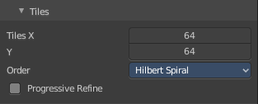
Tiles

Tile size X/Y
The size of the tiles for rendering.
Depending on what device you are using for rendering, different tile sizes can give faster renders. For CPU rendering smaller tiles sizes (like 32 x 32) tend to be faster, while for GPU rendering larger tile sizes give better performance (like 256 x 256).

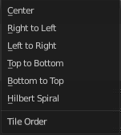
Order
Order of rendering tiles. This does not significantly affect performance.

Progressive Refine
Instead of rendering each tile until it has finished every sample, refine the whole image progressively. Note that progressive rendering is slightly slower than tiled rendering, but time can be saved by manually stopping the render when the noise level is low enough.
For rendering animations it is best to disable this feature, as stopping a frame early is not possible.

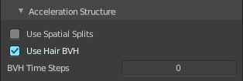
Acceleration Structure

Use Spatial Splits
Spatial splits improve rendering performance in scenes with a mix of large and small polygons. The downsides are longer BVH build times and slightly increased memory usage.

Use Hair BVH
Use a special type of BVH for rendering hair. The bounding boxes are not axis aligned allowing a spatially closer fit to the hair geometry. Disabling this option will reduce memory, at the cost of increasing hair render time.

BVH Time Steps
Is active when Spatial Splits is off. Split BVH Primitives by this number of time steps. This speeds up rendering, but requires more memory.

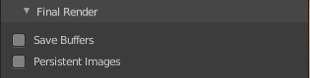
Final Render

Save Buffers
Saves all render layers and passes to the temp directory on a drive, and read them back after rendering has finished. This saves memory usage during rendering, particularly when using many render layers and passes.

Persistent Images
Keep image data in memory after rendering, for faster re-renders at the cost of extra memory usage when performing other tasks in Blender.

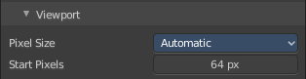
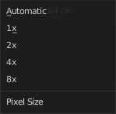
Viewport
This settings is for rendering in the Viewport.

Pixel Size
Pixel Size for Viewport Rendering.

Start Pixels
The resolution to start rendering at. And then progressively increase it to the full viewport rendering.

Cycles - Bake panel

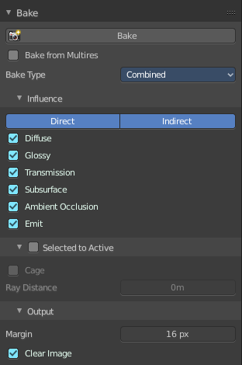
Texture baking is the process to bake specific informations from one object into the texture or the vertex colors of another object. Ambient Occlusion. Or a Normal Map for example.

NOTE
Baking into textures requires to have a working UV mapping and a texture at the target object!

How to use: Select the source object where you want to bake from, hold down Shift, select the target object where you want to bake to, so that both objects are selected. Adjust the settings to your needs. Then hit the Bake button.

NOTE
The Bake panel is visible in all Modes. But you have to bake in Object Mode.

Settings for all Texture types
Most settings in the Bake panel are available for all texture types.

Bake Button
Start the bake process.

Bake from Multires
Bake directly from multi resolution object.

Bake Type
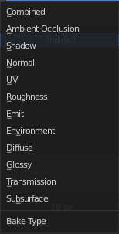
Bake Mode is a drop-down box to choose what type of information you want to bake from the source object into the texture or the vertex colors of the target object.
You can bake Subsurface, Transmission, Glossy, Diffuse, Environment, Emit, UV, Normal, Shadow, Ambient Occlusion and Combined.

Subsurface
Bakes the Subsurface Passes of a material into the texture of the target object.

Transmission
Bakes the transmission Passes of a material into the texture of the target object.

Glossy
Bakes the Glossy Passes of a material into the texture of the target object.

Diffuse
Bake the diffuse texture of the source object into the texture of the target object.

Environment
Bakes the Environment texture into the texture of the target object. As seen from the center of the object.

Emit
Bakes the Emission or the glow color of a material into the texture of the target object.

Roughness
Bakes the Roughness of a material into the texture of the target object.

UV
Bakes colors of materials and textures only, without shading.

Normals
Creates a Normal map by using the normals of the source object, and baking them as colors into the texture of the target object.

Shadow
Bakes the Shadow into the texture of the target object.

Ambient Occlusion
Bakes ambient occlusion as specified in the World panels. Ignores all lights in the scene.

Combined
Bakes the full rendering, means materials, textures, lightning, into the texture of the target object. Except Specularity.

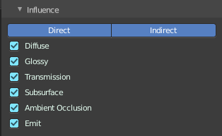
Influence Sub panel
Adjust what data contributes to the bake process. The items are self explaining.
The content changes, dependent of what type you want to bake.

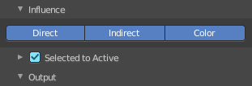
Subsurface, Transmission, Glossy, Diffuse

Direct
Add direct Light.

Indirect
Add indirect Light.

Color
Add Color.

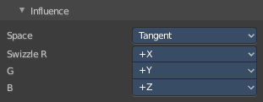
Normal

Space
A drop-down box to chooses the Normal Space to use.

Swizzle
Axis to bake in red, green and blue channels.

Combined

Direct
Bake directly from Multires mesh.

Indirect
Normalizes without using material settings.

Diffuse
Bake with Diffuse.

Glossy
Bake with Glossy.

Transmission
Bake with Transmission.

Subsurface
Bake with Subsurface.

AO
Bake with Ambient Occlusion.

Emit
Bake with Emit.

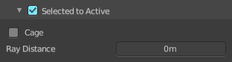
Selected to Active
The usual way to bake is first select the Source Object, where you want to bake from, hold down Shift, select the target object where you want to bake to, so that both objects are selected. Then hit the Bake button. That's Selected to Active.

Cage
This setting is hidden as long as Selected to active is not ticked.
Cast Rays to active object from a cage.

Ray Distance
Distance to use for the inward ray cast when using Selected to Active.

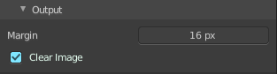
Output Sub panel

Margin
Adjust the margin width.

Clear Image
Clear clears the target image before baking.

Workbench - Lighting panel
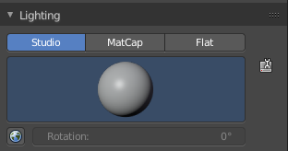
The Workbench renderer uses Open GL. OpenGL rendering is not influenced by the lights that you place in the workspace. But by a special OpenGL light setup. It can be tweaked in the Lighting panel and the User Preferences.

Flat
Use a flat lighting.

Studio
Use a Studio light setup.

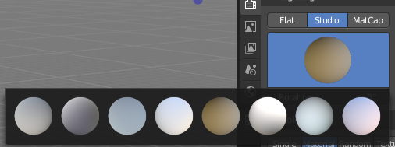
Light library browser
Choose a predefined studio light setup.

Rotation
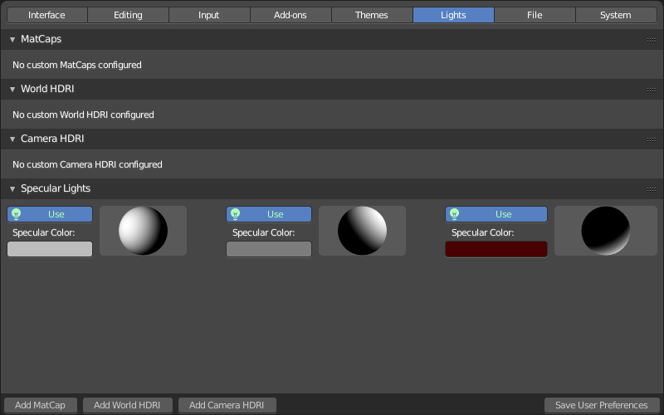
Rotate the studio light setup.

User Preferences
A click at this button opens up the user preferences where you can add and manage the OpenGL Lights.

Matcap
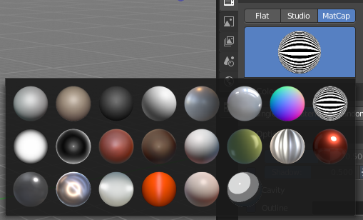
Use Matcaps to render the scene.

User Preferences
A click at this button opens up the user preferences where you can add and manage the Matcaps

Flip Matcap
Flips the matcap.

Workbench - Color panel

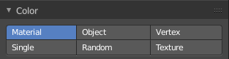
Workbench renderer is meant for fast preview display. It does not use materials like Eevee or Cycles. You choose a color instead.

This panel allows you to define the color of the surface of the object. This settings are also dependent of the chosen lighting.

Material
Uses the material including textures for the mesh.

Object
Uses the Object color.

Vertex
Uses the Vertex color.

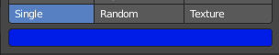
Single
Uses a single color for the selected mesh.

Random
Uses a random color for the mesh.

Texture
Renders the texture, and ignores the material settings.

Workbench - Options panel
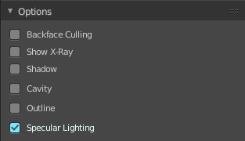

X Ray
Render the faces transparent.

Backface Culling
Don't calculate back faces.

Show X-Ray
Set X-Ray active, and adjust the amount of alpha that is used for the x-ray effect.
Note that you can have either X-Ray or Shadow and Cavity active. Not both at the same time.

X-Ray Alpha
This slider shows up when you tick Show X Ray. Adjust the intensity.

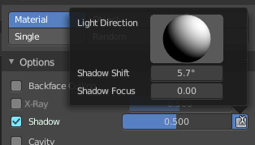
Shadow
Render Shadow.

Shadow Intensity
This slider shows up when you tick Shadow. Adjust the intensity.

Shading Shadow Options
Adjust a shadow shift relative to the light source.

Cavity
Show Cavity. Cavity highlights ridges and valleys in the scene geometry. Once activated Cavity shows some further settings.

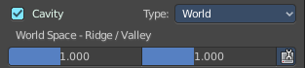
World
Draw the cavity shading in world space.

World Space / Ridge Valley
Factor for the cavity ridges and valleys.

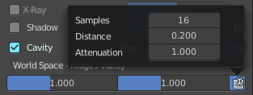
Shading Options
Adjust samples, distance and attenuation for the cavity ridges and valleys.

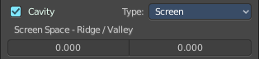
Screen
Draw the cavity shading in Screen space.

Screen Space / Ridge Valley
Factor for the curvature ridges and valleys.

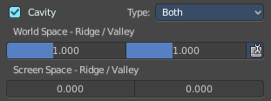
Both
Draw the cavity shading in both, World Space and Screen space.
Settings see above.

Outline
Show the not selected objects with an outline.

Outline Color
Define the color of the outline for not selected objects.

Specular Lighting
Render specular highlights.

Eevee - Sampling panel
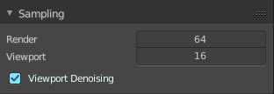

Viewport Samples
The number of samples when rendering in the viewport.

Render Samples
The number of samples when rendering to file.

Viewport Denoising
Denoise Image. The temporal re-projection can cause some ghosting.

Eevee - Ambient Occlusion panel
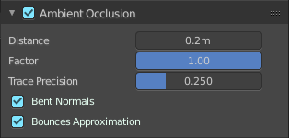
Ambient occlusion is a self shadowing effect.

Enable
In the header you will find a checkbox to enable the Ambient Occlusion.

Distance
The distance of the object to contribute to the ambient occlusion.

Factor
The blend factor

Trace Precision
Precision of the horizon search

Bent Normals
Compute the main non occluded direction to sample the environment

Bounces Approximation
An approximation to simulate light bounces gives less occlusion on brighter objects.

Eevee - Bloom panel

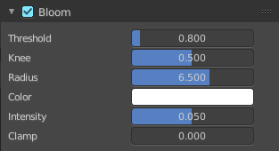
Enable
In the header you will find a checkbox to enable the Bloom.

Threshold
Filters out pixel that are below this level of brightness.

Knee
Makes transition between under / over threshold gradual.

Radius
Bloom spread distance.

Color
The color of the bloom effect.

Intensity
Blend Factor.

Clamp
Maximum intensity a bloom pixel can have.

Eevee - Depth of Field panel
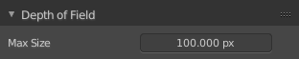

Max Size
The maximum size of the bokeh shape for Depth of Field. Lower is faster.

Eevee - Subsurface Scattering panel

Subsurface scattering is a mechanism of light transport through the object. It penetrates the surface of a translucent object, is scattered by interacting with the material, and exits the surface at a different point.

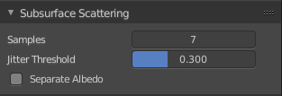
Enable
In the header you will find a checkbox to enable the Subsurface Scattering.

Samples
Number of samples to compute the scattering effect.

Jitter Threshold
Rotate samples that are below this value.

Separate Albedo
Avoid albedo being blurred by the subsurface scattering. This feature uses more memory.

Eevee - Screen Space reflections panel

Contains settings around the Screen Space reflections.

Screen Space Reflections is a common technique in games. It reuses the information that is already on screen for reflections. It doesn't reflect geometry outside of the camera though.

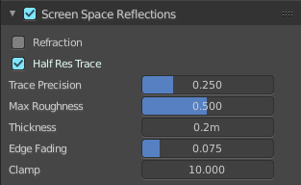
Enable
In the header you will find a checkbox to enable the Subsurface Scattering.

Refraction
Enable Screen Space refraction.

Half Res Trace
Ray trace at a lower resolution.

Trace Precision
The precision of the screen space ray-tracing.

Max Roughness
Do not ray-trace reflections that are above this value.

Thickness
Pixel thickness used to detect intersections.

Edge Fading
Screen percentage used to fade the Screen Space Reflection.

Clamp
Clamp Pixel intensity to remove noise.

Eevee - Motion Blur panel

Contains settings for motion blur.

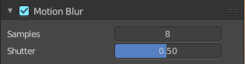
Enable
In the header you will find a checkbox to enable the Subsurface Scattering.

Samples
Number of samples for motion blur.

Shutter
Time taken in frames between shutter open and close.

Eevee - Volumetric panel

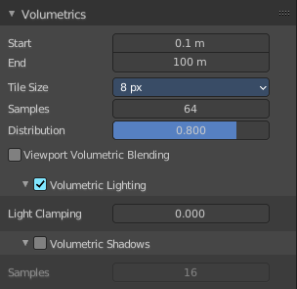
Contains volumetrics settings.

Start
The start distance for volumetrics.

End
The end distance for volumetrics.

Tile Size
The quality of the volumetrics effect. The lower the size the higher the quality and ram usage.

Samples
Number of samples to compote for the volumetrics effect.

Distribution
Distribute more samples closer to the camera.

Viewport Volumetric Blending
Enable volumetrics blending with previous frame in viewport. Attention, this setting is just for the viewport. The final rendering is not affected.

Volumetric Lighting

Enable
In the header you will find a checkbox to enable Volumetric Lighting.

Light Clamping
The maximum light contribution.

Volumetric Shadows

Enable
In the header you will find a checkbox to enable Volumetric Shadows.

Samples
Number of samples to compute volumetric shadowing.

Eevee - Hair panel

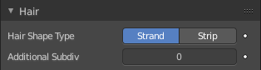
Hair Shape Type
Choose if the hair is displayed as strand or as strip.

Animate Property
This property can be animated. Activating this button sets a keyframe.

Additional Subdiv
Additional subdivision along the hair.

Animate Property
This property can be animated. Activating this button sets a keyframe.

Eevee - Shadows panel
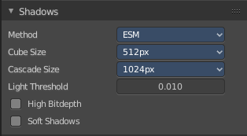
Contains settings regarding shadows.

Method
Choose between ESM and VSM method for the shadow. ESM stands for exponential shadow mapping. VSM stands for Variance shadow mapping.

Cube Size
The cube shadows resolution.

Cascade Size
Directional shadows resolution.

High Bit depth
Use 32 bit shadows. Low bit depth uses 8 bit.

Soft Shadows
Create soft shadows.

Eevee - Indirect Lighting panel
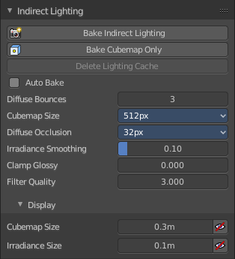
Indirect lighting can be baked to speed up the rendering process.

Eevee uses irradiance probes to calculate indirect lighting.

Bake Indirect Lighting
Bake both, the irradiance grids and reflection cube maps.

Bake Cubemap Only
Bakes only the reflection cube maps.

Delete Lighting Cache
Delete baked informations from cache.

Auto Bake
Auto bake indirect lighting when editing probes.

Diffuse Bounces
Number of times the light is reinjected inside light grids. 0 will disable indirect diffuse light.

Cubemap Size
The size of the cube maps.

Diffuse Occlusion
The size of the shadow map applied to each irradiance sample.

Irradiance Smoothing
Smooth the irradiance lightning. But this might introduce light bleeding.

Clamp Glossy
Clamp Pixel intensity to reduce noise inside glossy reflections from reflection cube maps. A value of 0 disables the clamping.

Filter Quality
Take more samples during cubemap filtering to remove artifacts.

Display

Cubemap Size
Size of cubemap spheres to debug captured light.

Irradiance Size
Size of the irradiance sample spheres to debug captured light.

Eevee - Film panel
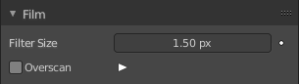

Filter Size
The width over which the reconstruction filter combines samples.

Animate Property
This property can be animated. Activating this button sets a keyframe.

Overscan
Internally render past the image borders to avoid screen space effects disappearing.

Overscan Size
How much bigger the image should be internally rendered.

Eevee + Workbench - Simplify panel
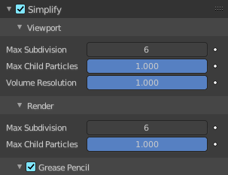
Sometimes you want to simplify the rendering without to loose the already tweaked settings and adjustments. For test renderings for example. Simplify allows you to simplify the rendering

.

Enable
In the header is a checkbox to enable Simplify.

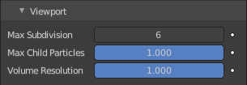
Viewport
This section affects the rendering with Eevee in the Viewport.

Max Subdivisions
Limit the number of maximum subdivisions.

Child Particles
Limit the number of child particles.

Volume Resolution
Simplify volumes by setting the resolution percentage of volume objects in viewport

Animate Property
This properties can be animated. Activating this button sets a keyframe.

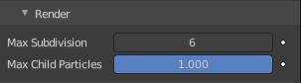
Render
This section affects the rendering with Eevee to file.

Max Subdivisions
Limit the number of maximum subdivisions.

Child Particles
Limit the number of child particles.

Animate Property
This properties can be animated. Activating this button sets a keyframe.

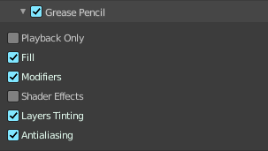
Grease Pencil
This section affects Grease Pencil drawings.

Playback Only
Simplify Grease Pencil only during animation playback.

Fill
Display Fill strokes in the Viewport.

Modifiers
Apply modifiers in the viewport.

Shader Effects
display shader effects.

Layers Tinting
Display layers tint.

Antialiasing
Use antialiasing to smooth stroke edges.

